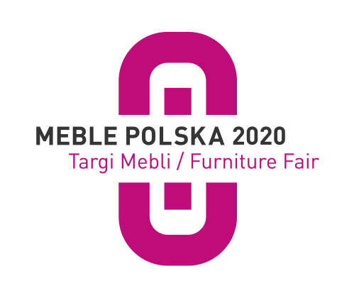
Poznań, Dezember 6th, 2020

MEBLE POLSKA 2020 Furniture Trade Fair coming in February

Not in March as usual but already on 25-28 February 2020, the next edition of MEBLE POLSKA fair - the largest furniture buying platform in Central and Eastern Europe - will be held in Poznań. The change of date is due to the growing importance of the event on global scene. The change will allow furniture buyers to participate in trade fairs in Poland who, so far, had chosen the trade fair marathon held in March in the Far East.

In the world's top
The MEBLE POLSKA 2020 - Furniture Fair is one of the most effective tools for promoting exports of Polish furniture which is listed in the elite group of the most important furniture industry trade fairs in the world. It is visited by furniture buyers from nearly 70 countries. In addition to a large group of traders representing the Polish retail network, the Poznan fair is visited by representatives of most large European buying groups and furniture chain stores, as well as many furniture wholesale distributors and online traders from other continents. In February 2020, the number of visitors is expected to be exceptionally high. - We already have confirmation that, thanks to the change of date, the highest-ranking furniture buyers, who did not have the opportunity to participate in our fair, will come to Poznań for shopping - says Józef Szyszka, director of the MEBLE POLSKA 2020 - Furniture Fair.

The largest exhibition of Polish furniture
The MEBLE POLSKA 2020 Furniture Trade Fair is the world's largest exhibition of the Polish furniture industry's offer. As usual, they are accompanied by the Home Decor Fair and the ARENA DESIGN event, which this time will be held under the theme "Slowness". In total, about 500 companies and brands will present their offers in 11 pavilions on the fair area.
The exhibition in 2020 looks exceptionally interesting. All leading Polish furniture manufacturers, who are interested in increasing their export, have announced their presence in Poznań. In addition to affordable furniture made of furniture board, the fair will also feature products made of solid wood and other high-end furniture. The exhibition of upholstered furniture and mattresses, in the production of which Poland is a world leader, also seems to be interesting. Following the example of other furniture fairs around the world, a part of the exhibition offered exclusively to key buyers with the largest purchase budgets will be presented within closed spaces (so-called secret rooms). Foreign companies, mainly from Eastern Europe, willingly participate in the furniture fair in Poznań. They want to reach furniture buyers who come to Poznań from all over the world. The interest in the organisation of the national stand was expressed, for example, by a cluster of furniture manufacturers from Ukraine. They recognised the MEBLE POLSKA 2020 - Furniture Fair as the main, strategic business exhibition of furniture in Europe, where all European buyers are gathered. Detailed information and a list of registered companies can be found at: www.meblepolska.pl
Focus on Polish design
Polish design is becoming more and more recognisable on international markets. It surprises with ingenuity and boldness. Therefore, during the MEBLE POLSKA 2020 Furniture Trade Fair, as part of the ARENA DESIGN event, you will be able to see two new exhibitions presenting the best Polish projects: FORMS OF THE FUTURE – THE ZONE OF POLISH DESIGNERS and the POLISH DESIGN VISIONER zone. The first one shows the most interesting projects of Polish designers, while the second one is devoted to the presentation of the best Polish brands that focus on visionary, bold and innovative design.

Free ticket only online
The registration of furniture buyers who wish to participate in the MEBLE POLSKA 2020 - Furniture Fair is now available on the Internet. Every day, dozens of representatives of reputed shopping groups and chains of furniture stores from all over the world register at www.mtp24.pl. Why should I register online? Only online registered representatives of the furniture industry can receive a free entrance ticket to the trade fair. Pre-registration on the Internet allows you not only to avoid queues at the entrance to the trade fair, but also to save money. Unlike the electronic ticket, which is free of charge, a handling fee of PLN 10 will be added to the paper ticket collected at the ticket counter at the entrance to the fair. The organiser – Grupa MTP - expects a total of over 20,000 visitors.
Furniture buyers with the greatest shopping potential will traditionally be able to use
a special service, where, apart from free admission to the fair and catering, they will be provided with help in organising their arrival, accommodation, an invitation to a trade evening and unlimited access to the Meeting Point area, which provides comfortable working conditions and full discretion necessary to hold business negotiations.

Online registration for the MEBLE POLSKA 2020 Furniture Trade Fair >>> www.meblepolska.pl

Report from the 2019 edition

https://www.youtube.com/watch?v=66CT87uF7aM&feature=emb_logo

