Meble Polska 2022 – Gold Medal laureates

- FORN

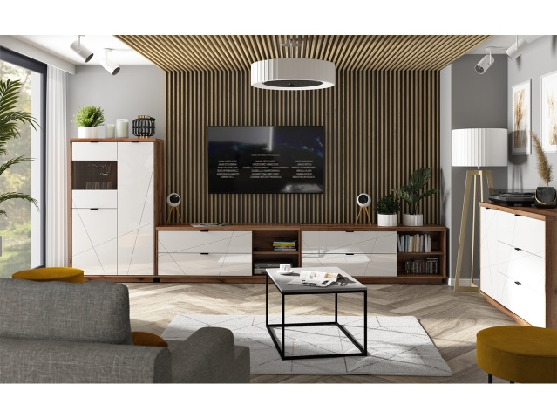
BLACK RED WHITE S.A.

The geometric form of the Forn collection perfectly reflects the most important features of the modern style, thanks to the decorative motifs of linear cutters that intersect the fronts in an attractive way. The comfort of the furniture users will be ensured by accessories that ensure smooth and silent closing of the fronts of cabinets and drawers. In addition, it is possible to install energy-saving LED lighting in the furniture. The collection includes a chest of drawers, a wardrobe, display cabinets, a shelf and a TV cabinet.

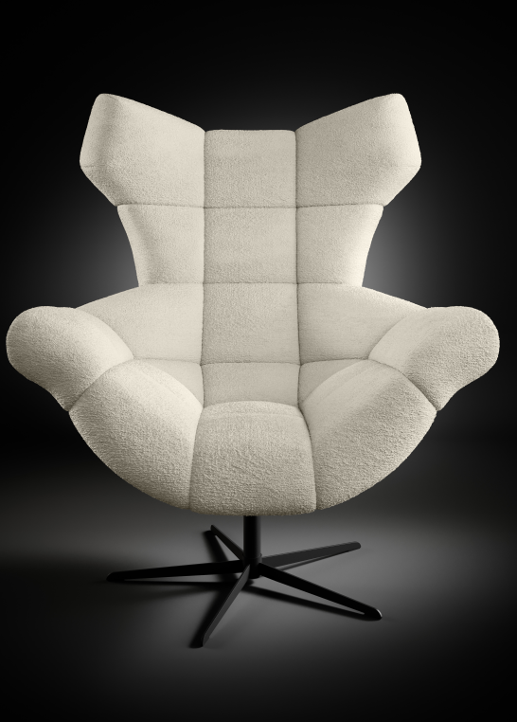
- SENSI Armchair

Fabryka Mebli WER-SAL Kaczorowscy Sp. j.

The SENSI armchair was created for everyone who is looking for a personal relaxation zone. The wide seat, perfectly profiled, high backrest surround the user, giving them a feeling of safe and comfortable rest. The designer form of the armchair with geometric stitching makes an amazing impression. Set on a swivel base, additionally equipped with a rocking function, it will ensure a perfect rest. The armchair will work in the living room, bedroom, office and youth room. Depending on the type and colour of the fabric, SENSI takes on a different character. The collection is complemented by a footrest, which together with the armchair make a harmonious duo.
- DIAMENT Furniture Collection

TARANKO Furniture Factory Aleksander Taranko

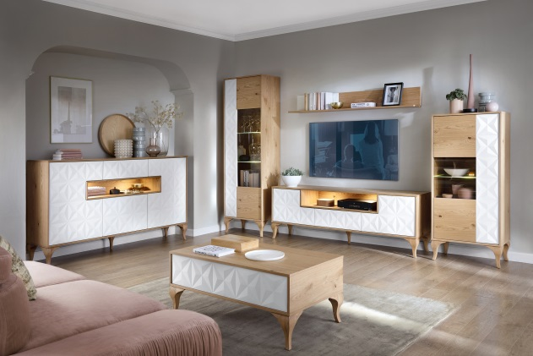
The DIAMENT collection is a new line of furniture for the living room and dining room in a modern style. The available modules are thought out and designed to take full advantage of the available space and thus guarantee maximum comfort of use. The open space inside the furniture allows for its free use and display of selected decorations and favourite souvenirs. The collection is made of oak wood, veneered chipboard and MDF board covered with matt PVC veneer. There are two colours available, white and graphite, which allows you to create a completely different interior arrangement. Depending on the light, the colour of the foil and the place where the piece of furniture stands, the unique pattern on the decorative front becomes more or less visible.

- MERANO Furniture Collection

TARANKO Furniture Factory Aleksander Taranko

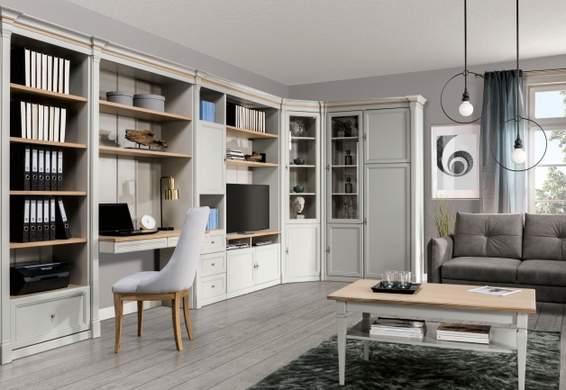
The idea of this collection is the possibility of arranging the office space individually by the customer who uses ready-made modules that are consistent in style and colour. The modules available in this collection are well thought-out and designed to take full advantage of the available space and guarantee maximum comfort. The unique light grey colour together with elements of warmly stained oak wood allows you to create a unique interior. The decorative columns, crowns and tops included in the system give the whole structure coherence and character. A wide range of products allows for any setting of furniture in order to efficiently and completely use the available space. In addition to the shelves, the system includes free-standing furniture such as tables and chests of drawers, as well as two types of desks with an innovative, retractable top that allows you to arrange a mini conference table.

- LAYMAN – Furniture system DESIGNE module

Layman Sp. z o.o. Sp. k.
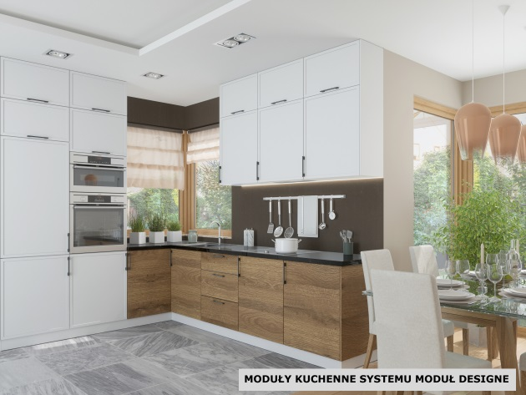
Open space, which is a combination of a kitchen, dining room and living room, has been the leading trend in arranging our flats for several years. The Layman Furniture Factory has created the first complementary furniture system on the market, the Design Module, for arranging Open Spaces. The Design Module system has solved the problem of searching for room furniture similar to kitchen furniture, which is common among customers, or vice versa. Our designers and technologists have created a system of kitchen and room modules coherent in terms of colour and material, creating a common design for the entire room.

- Mysti

Wajnert Meble Sp. z o.o.

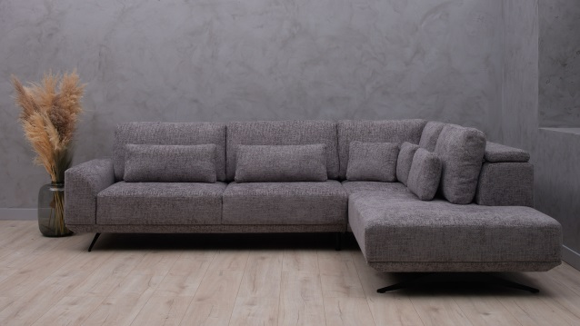
The Misty collection is distinguished by a combination of two extremely practical solutions: an electrically retractable seat, which significantly increases the usable space depending on the needs, and comfortable double back cushions with a lifting system that allows you to comfortably lean back. The collection premiered in the first quarter of 2022. at the internal fair of the Wajnert Meble company, where it aroused the greatest interest and enthusiasm among the visitors. This was also confirmed by the number of orders. The collection was appreciated not only for its practical functions, but also for its unique design and modularity, which allows the furniture to be adapted to the needs of a wider group.

- ASPEN Corner sofa

POLDEM Sp. z o.o. / STELLA Sp. z o.o.
A collection with a highly modernist character, i.e. a design line that fits perfectly into large interiors arranged in a modern style. The offer includes conventional sofas and a wide range of modules designed for various sizes of corner units. The system also includes pouffes that complement the main blocks.

- CELESTE Corner sofa

POLDEM Sp. z o.o. / STELLA Sp. z o.o.

The design form is definitely intended for large living rooms, large flats, loft spaces, etc. Dedicated in particular to modernist interiors. A large number of modules provides freedom in creating various corner configurations and arrangements, including simple sofas of various sizes. The CELESTE collection is a solution for people looking not only for a wide range of possibilities in the use of the living room space, but also for those who value above-average usability.

- FORIO Corner sofa

POLDEM Sp. z o.o. / STELLA Sp. z o.o.

A very extensive collection, including a large number of modules, consisting of conventional sofas and blocks for corner structures, additionally extended by two variants of pouffes complementing the main modules. The sofas manufacturing process meets the highest environmental and ergonomic standards. The furniture is available in a wide range of textile upholstery with a highly diversified design and colour scheme.

- POLYPODY

Fabryki Mebli FORTE SA
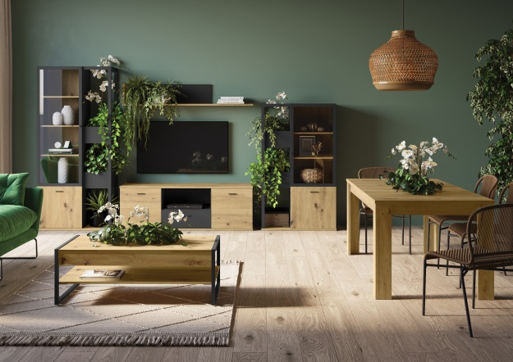
The POLYPODY furniture line is FORTE's response to the growing needs of customers who want to be surrounded by nature, also in their flats Chests of drawers, shelves, display cabinets, tables and coffee tables from the POLYPODY line, in addition to their basic function, allow you to display potted plants without the need to buy additional covers or stands. Each of the pieces of furniture has a special place for a pot. It is a recess with a perfectly fitted insert made of a water-repellent material.

